October 11, 2021
Whately Cultural Council Meeting via ZOOM
10:12 a.m. Meeting called to order
Present: Nancy Talanian, Rich Korpiewski, Julie Waggoner, Adelia Bardwell
Announcements:
- This meeting is being videotaped via Zoom.
- Julie’s last day on Whately Cultural Council is October 13.
- Three new members have volunteered to be on the Whately Cultural Council, they will be present and available for the grant allocations meetings for next year.
AGENDA:
To discuss authorizing funds for 2021 Whately Fall Festival, via Whately Historical Society. Funds were initially from 2020 allocation, held over until 2021 due to COVID.
Shall the CC approve the change of artists & authorize the costs: The Pandemic String Band, $100 (initial allocation for Sarah the Fiddler band, $300). The leftover $200 will be rolled into the Cultural Council’s total funds, to be awarded and distributed in 2022.
VOTES TAKEN:
Roll Call vote.
Unanimous YES, allocate $100 to Whately Historical Society for performance by Pandemic String Band.
Discussion / Information:
New grant applications are due October 15, 2021.
10:20 Meeting adjourned.

Respectfully submitted,
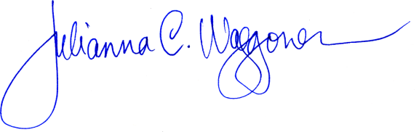

Julie (Julianna) Waggoner, Secretary
Whately Cultural Council

